**HOME WORK, WEEKS 9 AND 10**

**CLASS:** SS1 **TEACHERS’ PHONE NOS: 08030459602**

**SUBJECT:** TECHNICAL DRAWING **EMAIL: oluwarotimiaweda@gmail.com**

|  |  |  |  |
| --- | --- | --- | --- |
| 8 & 9 | Enlargement and  Reduction of Figures | Application of enlargement and reduction.  Reduction and enlargement of regular and irregular plain figures: triangles, quadrilaterals, polygons, etc. | Explain the applications of enlargement and reduction of  objects  Reduce given figures to given  proportions/ratios  Enlarge  given figures to given ratios |

**FILL IN THE BLANK SPACE**

1. In the diagram below, the figures ______ and ______ are in the ratio 2:5?

[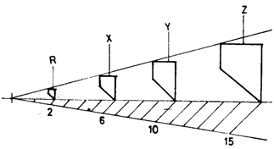](http://192.168.1.2/elims/exams/question/upquestion32340.jpg)

1. In the figure below PQRS and RSTU are parallelograms. If QT= 2, and SR = 3, the value of PU is _______

[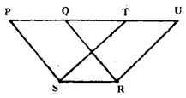](http://192.168.1.2/elims/exams/question/39133q_.png)

1. The ratio of line QR to line PR in the Figure is __________.



1. The figure below shows three irregular hexagons **J, K**, and **M.** ___:___:____ is the ratio of their sides.

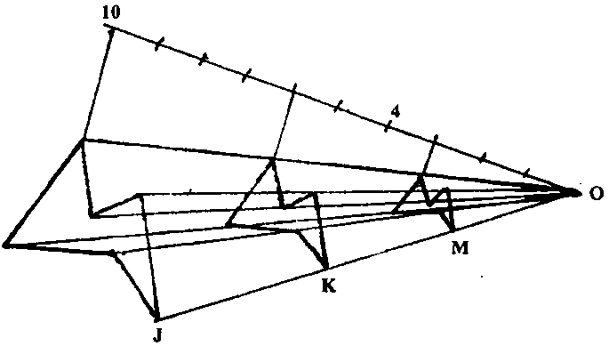

5. In order to enlarge linear size, first divide the plane shape into __________ and extend the lines.

6. When enlargement is done using poles, it is called ____________ enlargement.

7. Enlargement of area is based on _______________ theorem.

8. In enlargement of area, when the hypotenuse is √2 and the other sides are unity the enlarged square is ___________ the area of the given square.

9. In enlargement of area, when the hypotenuse is √3 and the other sides are unity and √2, the enlarged square is ___________ times the area of the given square.

10. In enlargement of area, when the hypotenuse is √4 and the other sides are unity and √3, the enlarged square is ___________ times the area of the given square.

11. A very large object can be drawn on paper by using ____________ of figures.

12. The primary unit of measurement for engineering drawings and design in the mechanical industries is the ________________.

13. The two triangles __________ and ____________ have the same area in the figure below.

[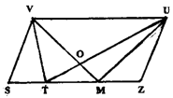](http://192.168.1.2/elims/exams/question/39134q_.png)

14. when the size of a small object is increased when drawn, the new drawing is an ______________ of the previous one.

15. A _____________ polygon has one of its internal angles more than 180°.

16. The plan of a cone is _______________.

17. The point where a line penetrates a plane is called _______________.

18. The line shown below is a __________ line.

[...](http://192.168.1.2/elims/exams/question/upanswer7130.jpg)

19. The plane shape, Rhombus, is a type of __________________ that all have four sides.

20. The figure shown below is a symbol for _____________________ projection.

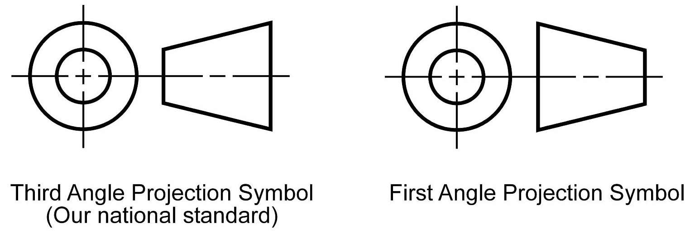

**ESSAY QUESTION**

1. Draw a quadrilateral ABCD, then construct a similar figure having half of the area of ABCD.

AB= 70mm BC=90mm

CD= 80mm AD=60mm ABC=700

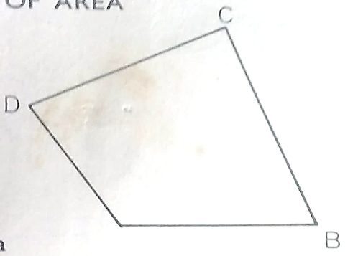

2. Extend this figure, using polar enlargement, so that the 50mm side measures 85mm on the new figure, keeping the same proportions.

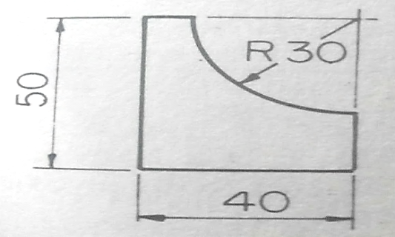

***EXAMINER: AWEDA, EMMANUEL O.***